CSA15 – Cloud Computing
CO1 – Assessment Task 1 (AT1)
Digital Concept Map & Cloud Architecture Design
Project Chosen: Smart Campus Attendance & Analytics System (SCAAS)

Student Name: Edrin S
Register Number:192524041
File Name: CSA15_CO1_AT1_RegisterNumber_Concept_Map.drawio
Date: 20 July 2026

Task 1: Concept Map
The concept map below connects the cloud ecosystem, cloud actors, service models, deployment models, virtualization, web services, REST/SOAP APIs, scalability, and elasticity to the chosen project, the Smart Campus Attendance & Analytics System (SCAAS). SCAAS is a web and mobile application that marks student attendance using camera-based face recognition, stores evidence in the cloud, and exposes REST APIs to a Python-based AI module.
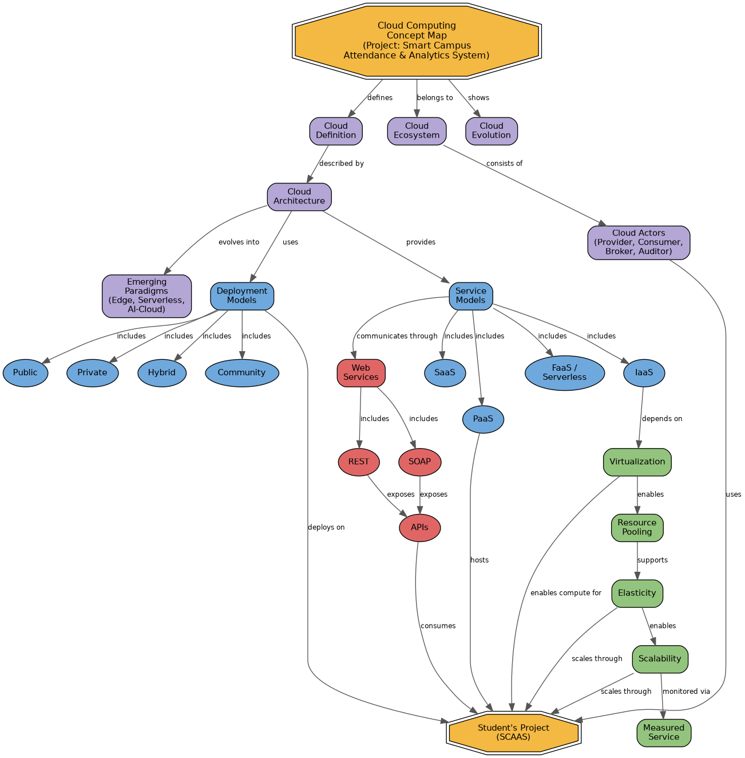

Color Legend
- Yellow (title nodes): the concept map title/anchor and the student's Project node.
- Purple: core cloud-ecosystem nodes (definition, evolution, architecture, actors, emerging paradigms).
- Blue: service models and deployment models.
- Green: cloud characteristics (virtualization, elasticity, scalability, pooling, measured service).
- Red: API and web-service concepts (SOAP, REST, APIs).
Labeled arrows describe the relationship type between nodes, for example “depends on” (IaaS → Virtualization), “enables” (Elasticity → Scalability), “communicates through” (Service Models → Web Services), and “scales through” (Elasticity/Scalability → Project).

Task 2A: Service Model Responsibility Matrix
The matrix compares eight service categories used across the cloud ecosystem and states what the cloud provider manages, what the student's application team manages, and why that split fits SCAAS.
Service Category | Managed by Cloud Provider | Managed by Application Team | Why This Split Fits SCAAS
SaaS | Entire application stack, OS, runtime, patching, availability. | Configuration, user roles, and data entered into the tool. | SCAAS uses a SaaS email/SMS gateway for notifications, so the team only configures templates instead of running mail servers.
PaaS | OS, runtime, middleware, container orchestration, auto-scaling infrastructure. | Application code, business logic, environment variables, deployment pipelines. | The backend API and AI/Python module are deployed on a managed PaaS/container platform so the team focuses on attendance logic, not server patching.
IaaS | Physical servers, hypervisor, virtual networking, virtualized storage. | Guest OS hardening, installed libraries (OpenCV, dlib), security patches on the VM. | Batch face-recognition training needs a GPU-backed VM, so IaaS gives the team low-level control over the runtime environment.
FaaS / Serverless | Servers, scaling, execution runtime, cold-start management. | Function code, trigger configuration, memory/timeout limits. | Lightweight, event-driven jobs (e.g., sending an absentee alert) run cheaply as serverless functions without idle server cost.
Database-as-a-Service | Database engine installation, patching, replication, automated backups, failover. | Schema design, queries, indexes, and row-level access rules. | Attendance and user records need a reliable managed SQL database without the team operating DB servers.
Storage-as-a-Service | Storage hardware, redundancy, durability, geo-replication. | Bucket/folder structure, lifecycle and retention policies, access permissions. | Attendance photo evidence is stored as objects with versioning and an automatic retention/lifecycle policy.
Identity-as-a-Service | Identity infrastructure, token issuance, MFA, password infrastructure. | Role definitions (student/faculty/admin), user provisioning, app-side integration. | Centralized login avoids the team building and securing a custom password store for three different user roles.
Monitoring / Logging | Log storage infrastructure, dashboard engine, alert-delivery infrastructure. | Deciding what to log, setting alert thresholds, building custom dashboards. | The team must track API latency, failed logins, and AI-module errors without building its own log pipeline.

Task 2B: Cloud Service Decision Matrix
The matrix below maps each SCAAS module to a specific cloud service category and justifies the choice, favoring the services that are actually relevant to the project rather than forcing every possible cloud service into the design.
Project Module | Cloud Service Selected | Justification
Authentication | Managed Identity-as-a-Service (OAuth2 / OpenID Connect provider) | Centralizes secure login for students, faculty, and admins and avoids storing raw passwords in the application database.
Frontend Hosting | Static hosting + CDN | The React web app is static after build, so a CDN gives fast, globally cached delivery at low cost.
Backend / API Layer | PaaS container platform with auto-scaling REST API | The API load varies sharply at class start/end times, so a managed, auto-scaled platform avoids over-provisioning idle servers.
Database | Managed relational Database-as-a-Service | Attendance, user, and course records are structured and relational, and need automated backups and failover.
Object Storage | Cloud object storage bucket | Attendance photo evidence is unstructured and needs durable, versioned storage separate from the relational database.
Analytics / Logging | Managed logging and analytics service | Centralizes logs from the API and AI module so anomalies (e.g., repeated failed recognitions) can be queried in one place.
Notification | Serverless function triggered by database/API events, paired with an email/SMS gateway | Notifications are infrequent, event-driven bursts, which fits the pay-per-execution serverless model well.
AI / Python Module | Containerized inference service on PaaS, with GPU-backed IaaS VM for periodic retraining | Real-time face-recognition inference fits a managed container; heavier periodic model retraining needs dedicated GPU compute.
Security | Web Application Firewall, IAM roles, and a managed secrets manager | Protects the public API gateway and keeps database credentials and API keys out of source code.
CI/CD | Managed CI/CD pipeline (build → test → deploy) | Automates testing and deployment of the frontend, backend, and AI module on every commit, reducing manual errors.
Backup | Automated snapshot and backup service for the database and object storage | Guarantees recovery of attendance records and photo evidence in case of accidental deletion or outage.
Monitoring | Cloud monitoring and alerting service | Tracks uptime, response latency, and error rates for the API and AI module, alerting the team before users notice issues.

Task 3: API Flow, Elasticity, and Scalability Design
The diagram below is a professional cloud-flow diagram for SCAAS. It shows the user/mobile app, the API gateway, the authentication service, the compute layer (backend API and AI/Python module), the database, object storage, analytics/logging, monitoring, the security boundary at the edge, and the auto-scaling point in the compute layer.
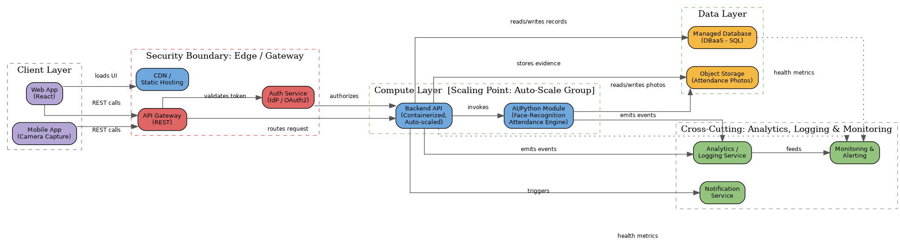

Flow Description
- The Web App and Mobile App call the API Gateway over REST; the Web App's static assets are served separately through a CDN.
- The API Gateway sits inside the security boundary and forwards every request to the Auth Service for token validation before it reaches the Backend API.
- The Backend API invokes the AI/Python Module for face-recognition inference; the module reads and writes attendance photos in Object Storage.
- The Backend API reads and writes structured attendance records in the managed Database and stores photo evidence in Object Storage.
- The Backend API triggers the Notification Service and emits events to the Analytics/Logging service; the AI module also emits its own events.
- Logging feeds the Monitoring & Alerting service, which also polls health metrics from the Database and Backend API (dotted lines).
- The scaling point is the Compute Layer: the Backend API and AI Module run in an auto-scale group that adds instances under load and removes them when demand drops — this is where elasticity and scalability are enforced.

Task 4: Technical Justification
This section explains how the concept map and both matrices together demonstrate CO1 (understanding of core cloud computing principles), covering service model selection, API role, elasticity, scalability, virtualization/managed compute choice, and cloud responsibility boundaries.
Service Model Selection. SCAAS deliberately mixes service models instead of using one for everything. PaaS hosts the backend API and the AI/Python inference service because the team needs to ship application code quickly without managing servers. A GPU-backed IaaS VM is reserved only for periodic model retraining, where the team needs low-level control over drivers and libraries that a PaaS environment would not expose. FaaS handles small, bursty tasks like notifications, since paying only per execution is cheaper than running an always-on server for infrequent events. This mix shows that service-model choice should follow workload shape, not convenience.
Role of APIs. REST APIs are the single contract between the mobile/web clients, the backend, and the AI module. Every attendance mark, whether captured on a phone or a classroom kiosk, passes through the same API Gateway, which keeps business logic centralized and lets the frontend, backend, and AI module evolve independently as long as the API contract is respected. Routing every request through the gateway is also what enables one authentication check to protect the entire system rather than each service authenticating separately.
Elasticity and Scalability. Attendance load is sharply bursty: almost every student checks in within the first five minutes of a class period, then the system is nearly idle. Elasticity lets the compute layer add instances automatically for that burst and shrink back afterward, so the project pays only for capacity it actually uses. Scalability is designed in separately from elasticity: the database uses read replicas and the object storage scales horizontally by design, so growth in the number of enrolled students or campuses does not require a redesign, only more allocated capacity.
Virtualization and Managed Compute Choice. Virtualization underlies every managed compute option used here — containers on PaaS and the GPU VM on IaaS are both virtualized resources shared across many tenants on the same physical hardware. Choosing PaaS for the everyday API workload accepts less control over the OS in exchange for the provider handling patching and scaling; choosing IaaS for GPU retraining accepts more operational responsibility in exchange for the hardware access that face-recognition model training needs.
Cloud Responsibility Boundaries. The Service Model Responsibility Matrix (Task 2A) makes the shared-responsibility model explicit for each service category used in SCAAS: the provider always owns the physical infrastructure and, for managed services, the runtime and patching, while the application team always owns its own code, configuration, and access rules. Keeping this boundary explicit is what let the team choose IDaaS for login instead of building a custom auth system, and DBaaS for storage instead of operating a database server — in both cases the team offloaded operational risk it did not need to carry.

Reflection Questions
1. Evaluate the effectiveness of your concept map in representing cloud computing principles. Which design decisions most strongly support your solution, and why?
The concept map is effective because it does not just list cloud terms, it links them with directional, labeled relationships that mirror how the concepts actually interact — for example, showing that elasticity “enables” scalability rather than treating them as synonyms. The strongest design decision was color-coding by category (characteristics, service models, API concepts, title nodes), which makes the diagram scannable at a glance and lets a viewer immediately separate “what the cloud is” from “how SCAAS uses it.” Anchoring the Project node with multiple incoming edges (from service models, APIs, elasticity, and deployment models) also makes clear that SCAAS is not a side note but the concrete instance of every abstract principle on the map.
2. Analyze how scalability, elasticity, and resource management influence the architecture shown in your concept map. What challenges could arise if these capabilities were absent?
Scalability and elasticity directly shaped the compute layer decision: because attendance check-ins spike sharply at the start of each class, the backend and AI module were placed in an auto-scaling group rather than on fixed-size servers. Resource pooling through virtualization is what makes that scaling economical, since the same physical hardware serves many tenants and can be reassigned on demand. Without elasticity, the system would have to be provisioned for peak load at all times, wasting money during idle periods, or it would be under-provisioned and fail during the exact five-minute window when every student is checking in. Without scalability, growth in enrolled students or additional campuses would force a full redesign instead of simply adding capacity, and without deliberate resource management the shared infrastructure could suffer noisy-neighbor performance problems during peak attendance windows.
3. Justify the selection of the APIs, web services, or cloud services included in your concept map. How do they contribute to the overall functionality and efficiency of the system?
REST was chosen over SOAP for SCAAS's client-facing APIs because attendance data is simple, stateless, and JSON-friendly, and REST's lower overhead suits frequent, small requests from mobile devices on variable networks. Managed cloud services were selected wherever the underlying operational work (patching, replication, scaling) is not something the student team needs to learn to deliver the project, which is why DBaaS, object storage, IDaaS, and PaaS all appear in the design. This combination keeps the system efficient in two ways: fewer network round-trips because REST calls map directly to attendance actions, and lower operational overhead because managed services absorb the infrastructure work that would otherwise slow the team down.
4. Critically examine the relationships between the components in your concept map. How do these interactions improve reliability, performance, or user experience?
Routing every client request through a single API Gateway that first checks with the Auth Service improves reliability by enforcing one consistent security check instead of duplicating auth logic across services, which reduces the chance of an inconsistent or missed check. Separating the database (structured records) from object storage (photo evidence) improves performance, since each store is optimized for its own access pattern instead of forcing photos into a relational database. The dotted monitoring links from the database and backend into the Monitoring & Alerting service mean problems are surfaced before students notice failed check-ins, which directly protects user experience during the narrow time window when attendance is actually being marked.
5. Reflect on the process of developing your concept map. How has creating and analyzing the map changed your understanding of cloud computing architecture, and what improvements would you make if you were redesigning it?
Building the map made the difference between cloud characteristics (elasticity, scalability, pooling) and cloud service models (SaaS, PaaS, IaaS) much clearer, since drawing explicit “depends on” and “enables” arrows forced a decision about which concept actually causes which, rather than listing them side by side. It also showed how much of the architecture is driven by one property of the project — bursty, time-windowed load — which shaped the compute, elasticity, and notification decisions together rather than in isolation. If redesigning it, I would add a disaster-recovery/backup branch connecting explicitly to the database and object storage nodes, since backup and recovery were addressed in the decision matrix but are under-represented as a labeled relationship on the concept map itself.

README Summary
Title: CSA15_CO1_AT1 – Smart Campus Attendance & Analytics System (SCAAS) – Cloud Architecture Evidence
Tools Used: draw.io / diagrams.net for the concept map and architecture diagram; Google Docs/Word for the written matrices and justification; GitHub for version-controlled submission.
Repository Structure:
- /concept-map – CSA15_CO1_AT1_RegisterNumber_Concept_Map.drawio, exported .png/.pdf
- /architecture – API flow diagram source and exported .png/.pdf
- /matrices – Service Model Responsibility Matrix and Cloud Service Decision Matrix
- /docs – this CSA15_CO1_AT1 Word document and README.md
CO1 Reflection: This submission demonstrates CO1 by tracing a single project (SCAAS) through every layer of cloud computing theory covered in the course — service models, deployment models, virtualization, elasticity, scalability, and REST-based web services — and showing, with justified evidence, how each principle maps onto a real architectural decision rather than staying abstract.

